Contents
1. Overview 2
2. Navigation 3
3. Viewing reference data in the Portal 3
4. Adding or amending reference data in the portal 4
4.1. Add new entry 4
4.2 Amend a Description 5
4.3 Deleting a data item 5
4.4 Removing a data item from use 6
5. Viewing reference data in the back office 6
6. Amending reference data in the back office 7
6.1. Amend a Description 7
6.2. Add new entry 8
6.3. Deleting a data item 8
6.4. Removing a data item from use 9
7. Variations 10
7. 10
7.1. Activity Codes – Back Office 10
7.2. Address Types – Back Office 10
7.3. Advertiser Details 11
7.4. Advertiser Profile 11
7.5. Advertising Codes - Portal 12
7.6. Applicant Status – Portal 13
7.7. Applicant Status Sequence - Portal 14
7.8. Bank Sort Code – Back Office 16
7.9. Company Settings 16
7.10. Contact Types - Portal 17
7.11. Education Codes (Qualifications) - Portal 17
7.12. Employee Status - Portal 18
7.13. Ethnicity Codes (Ethnic Types) - Portal 18
7.14. FTE Hours - Portal 19
7.15. Job Title Codes - Portal 19
7.16. Marital Status 20
7.17. Pay Methods – back office 20
7.18. Pay Scale, Point and Rates 20
7.19. Personnel Numbering – back office 21
7.20. Profile Analysis Codes 21
7.21. Reason Codes - Portal 22
7.22. Personal Title – Portal 22
7.23. Leaving Reason – Portal 23
7.24. Leaving Destination - Portal 24
7.25. Location after Leaving - Portal 25

Document Version Control
Change History/Review Details
Date | Version | Review by | Summary of Change
16/12/20 |  | HC | Updated following the implementation of V28 in the Portal
1/9/21 |  | HC | Updated to add Leaving reason codes and further edits following the move to the Portal
4 Nov 22 |  | HC | Updated to reflect screens that have moved to the Portal since the last update

Knowledge Article: Maintain Reference Data

Other related documents
Online application forms
Managing the org structure
Grades and Rates
UDFs
Language Pack CDD and HOW TO
Dashboard CDDs and How Tos

Overview

- Reference data is held in a number of different locations within the system.

- Some Recruitment reference data is held within Personnel.

- For detailed information on how the Core Reference fields have been utilised please refer to the following documents:

- Reference Data Master (RDM)

- For details on how to maintain the org structure reference data including Department, Management Units, Cost Centres etc please refer to:

- HOW TO View and Maintain Org Structure

- The steps below explain how to add, amend or delete the different types of reference data contained in the system.

 | NB: All changes described are subject to the agreed Change Control process. Refer to the knowledge article before making any changes.

Most Reference data tables are of a similar format. Each data item comprises a Code and Description and in some cases Analysis Codes may be used for reporting purposes. Variations are explained in detail in later sections of this document.

Navigation

Most People Management reference data items can now be found in the Portal:

Core|Portal>People Management>Data Centre>Reference Data

Available items are listed in alphabetical order. If you cannot find the item you need here check the back office:

Core Personnel > Reference > then choose from ……..

Reference A - C
Reference D - J
Reference K - P
Reference Q - Z

 | If you still can’t find the entry you want try Reference Q –Z > Other References.

Some Recruitment reference data is also found here, otherwise go to

Personnel > Recruitment > Recruitment Reference

Even though Recruitment has been migrated to the portal most of the reference data is still configured in the back office. However if you can't find what you're looking for try -

Core|Portal>People Management>Data Centre>Reference Data

Viewing reference data in the Portal

Most screens will look like the below with a filter to ‘search’ for a specific item, a slider to scroll up and down, and an ellipses (…) which may give you edit options if applicable.

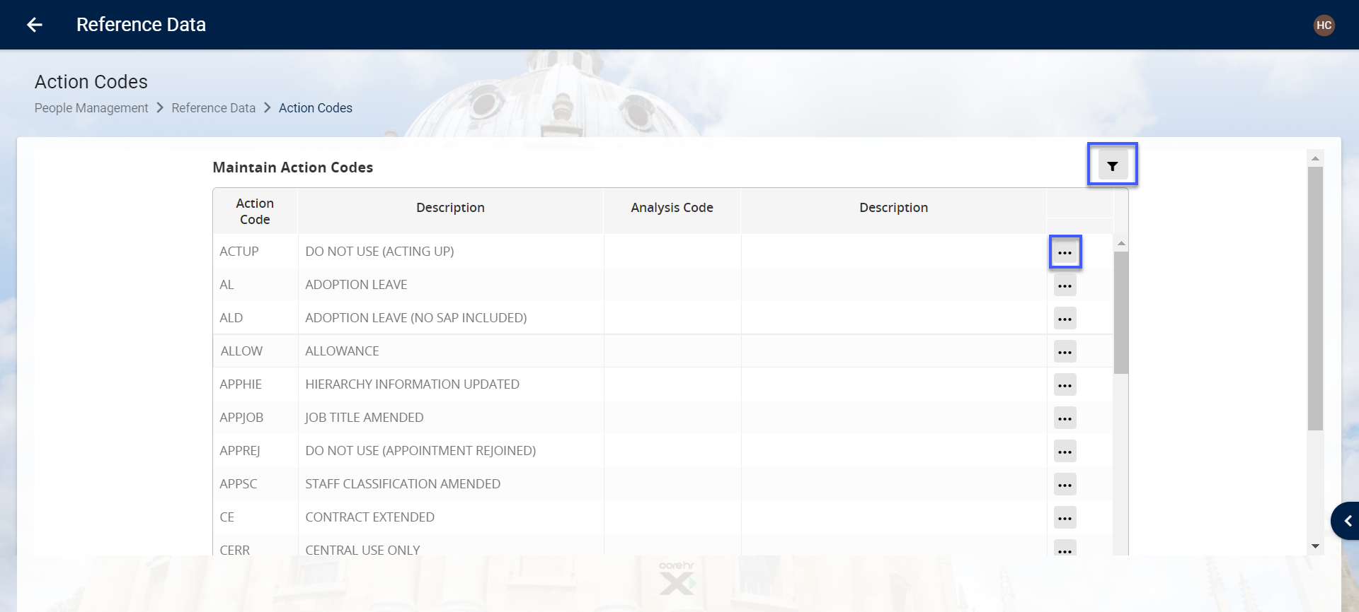

Some include toggle buttons

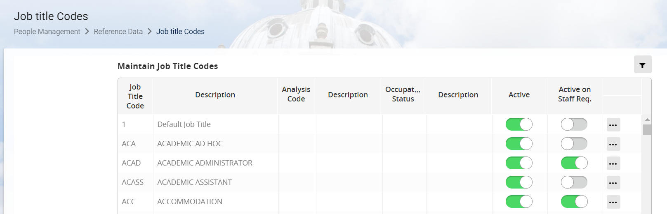

Adding or amending reference data in the portal

Add new entry

- Navigate to the relevant Reference area.

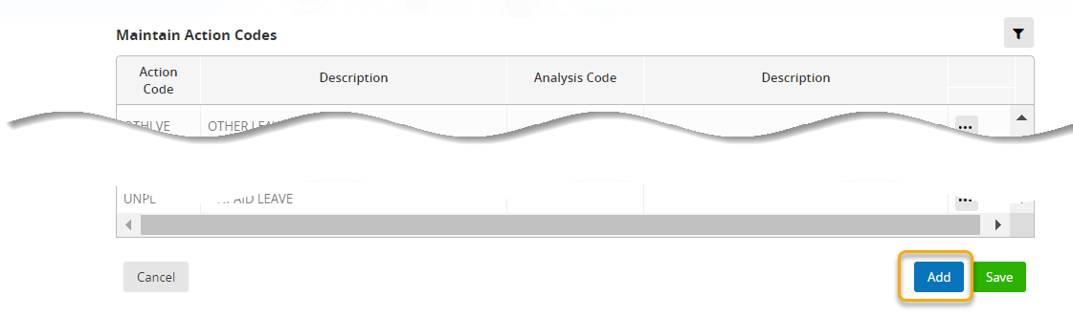

- Click on Add at the bottom of the screen to insert a new row

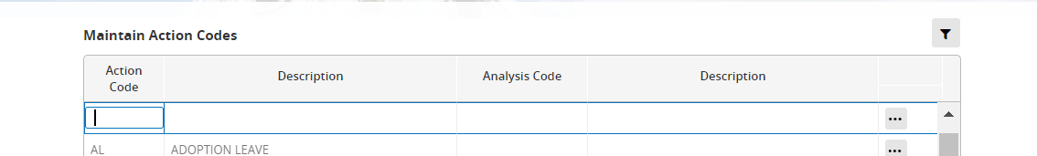

- Enter the Code and Description and SAVE

 | NB: The code and description values should have been agreed as part of the change control process.

- Use the breadcrumb trail to exit the screen.

Amend a Description

- Navigate to the relevant Reference area.

- Search for the data item to be amended and click into the Description field. A blue border will appear.

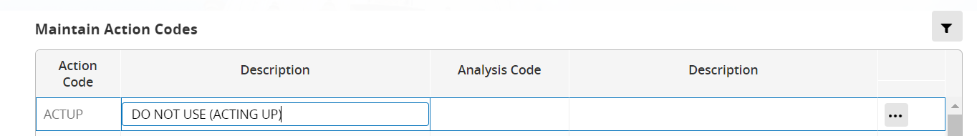

- Amend as required and SAVE.

- Use the breadcrumb trail to exit the screen.

Deleting a data item

 | NB: Reference data items can only be removed if they are not being used in the database. In the portal some items can be marked as inactive. They remain on the data tables but are not available for users to select.

To check if an item is in use anywhere in the database tables run or create a Discoverer report. If the item is not in use then you can proceed to remove the entry.

- Navigate to the relevant Reference area.

- Click on the item to select it (highlighted in blue).

If the system detects that the item is still in use then an error message will appear.
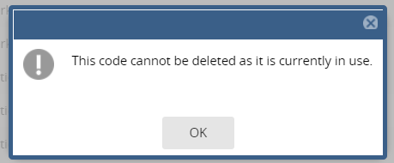

Removing a data item from use

If the item is in use and the database records are not going to be updated then rename the entry to reflect the fact that it should no longer be used.

- Navigate to the relevant Reference area.

- Click on the item to select it, then click on the Ellipses (…) and choose delete.
This has not been tested.

- If the item cannot be deleted prefix the Description with ‘Z – DO NOT USE’ and if available untick the Active box.

 | NB: you may need to abbreviate the original Description as there will be a character limit on the field.

Un-ticking the active flag will remove the item from some drop-down lists – but not necessarily all.

- Review the actual List of Values (LoV) in the Portal to ensure your changes are as expected.

Viewing reference data in the back office

Some screens will display reference data upon opening, others open in query mode enabling you to search for the item you wish to view.

For example - to View Country Codes go to Reference A – C > Country Codes. The screen automatically opens with the Country Codes displayed.

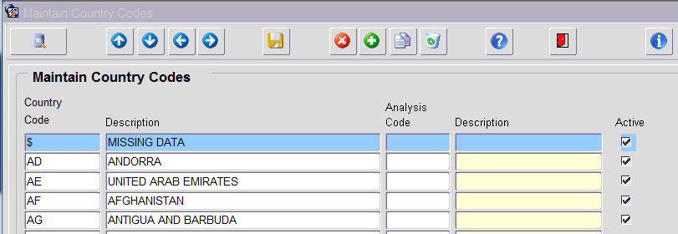

- Use the scroll bar or Page Up and Page Down arrows to move through the list.

- To search for an individual item click on the button to switch to query mode.

 | NB: If the screen opens in Query Mode you can click on F8 or the Execute Query button 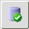 to return all data.

- To search for a specific item enter search criteria in the relevant field using % to represent wild card if necessary e.g. %united%. Click on the Execute Query button .

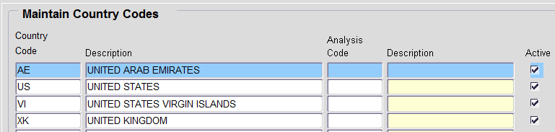

Amending reference data in the back office

Amend a Description

- Navigate to the relevant Reference area.

- Search for and select the data item to be amended.

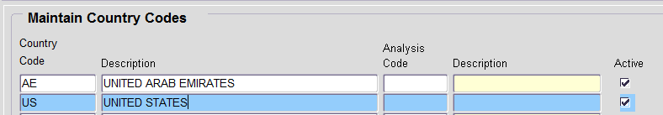

- Click into the Description field and amend as appropriate.

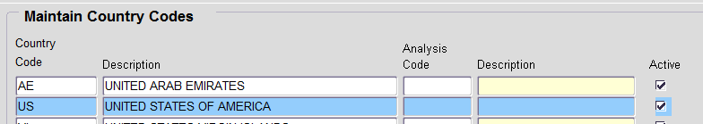

- Save and Red door to exit.

Add new entry

- Navigate to the relevant Reference area.

- Ensuring you are in Data Entry Mode i.e. you can see this icon at the top of the screen click into the next empty row or click on the Add icon  to insert a new row.

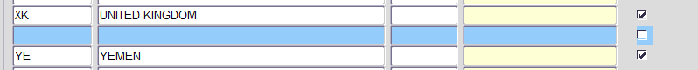

- Enter the Code and Description and if available tick the Active box.
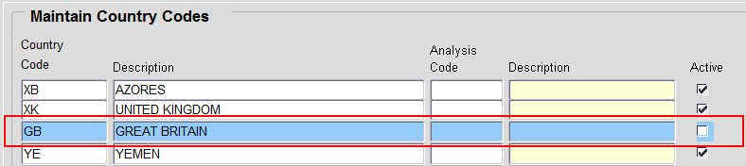

 | NB: The code and description values should have been agreed as part of the change control process.

- Click on Save then Red door to exit.

Deleting a data item

 | NB: Reference data items can only be removed if they are not being used in the database.

To check if an item is in use anywhere in the database tables run or create a Discoverer report. If the item is not in use then you can proceed to remove the entry.

- Navigate to the relevant Reference area.

- Click on the item to select it (highlighted in blue).

- Click on delete the current record  to delete the row.

If the system detects that the item is still in use then an error message will appear.
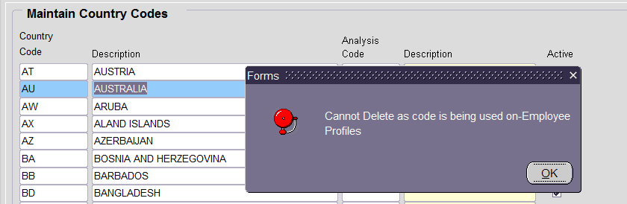

- Rerun the Discoverer reports taking care to include minimal filters.

Removing a data item from use

If the item is in use and the database records are not going to be updated then rename the entry to reflect the fact that it should no longer be used.

- Navigate to the relevant Reference area.

- Click on the item to select it (highlighted in blue).

- Prefix the Description with ‘Z – DO NOT USE’ and if available untick the Active box.

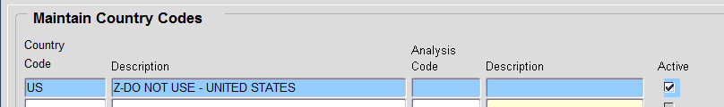

 | NB: you may need to abbreviate the original Description as there will be a character limit on the field.

Un-ticking the active flag will remove the item from some drop down lists – but not necessarily all.

- Review the actual List of Values (LoV) in the back office to ensure your changes are displayed as expected.

Variations

Activity Codes – Back Office

Activity codes are used to categorise cost centres.

Personnel > Reference > Reference A-C > Activity Codes

- Instead of an active flag there is a Disable flag.

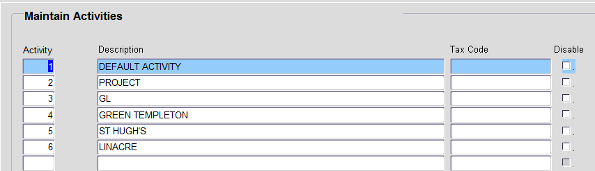

 | NB: Check the Core manual for more information before using this option.

Address Types – Back Office

Address types are used in Recruitment and Personnel.

Personnel > Reference > Reference A-C > Address Type Codes

- To view an existing address type, select the item from the LoV then click on Search.

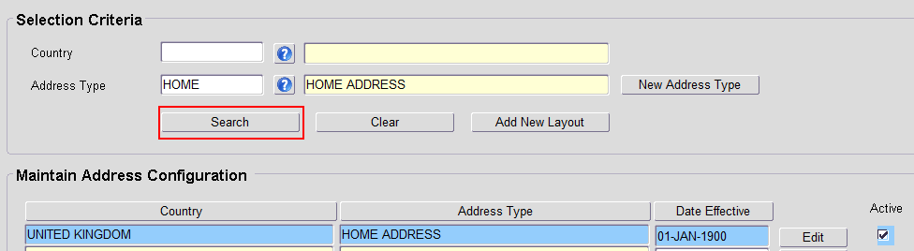

- To add a new item click on New Address Type

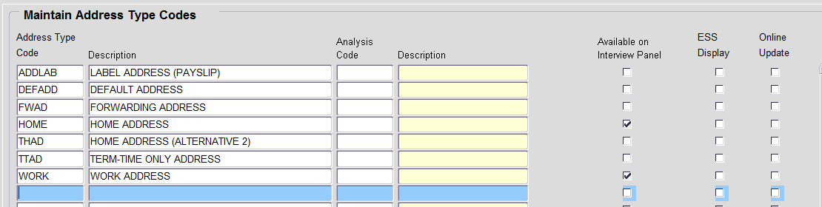

- Enter the Address Type Code and Description.

- If required tick Available on Interview Panel.

 | NB: It is also possible to control which contact types are available to view and update via ESS but these are not currently in use.

- Save and Red door to exit

Advertiser Details

Advertiser details are used to record the costs associated with using external advertising bodies on staff requests and/or vacancies.

A new Advertiser Profile will always need to be created but a new Advertising Code will not always be necessary. For example if a new profile is being created for an employment agency, the existing advertising code REAG – RECRUITMENT AGENCY will apply.

Advertiser Profile

Recruitment>Recruitment Reference>Advertiser Profile

- Click on New Advertiser and enter the Advertiser Name in the Add Advertiser screen.

- Click OK to save and exit the screen.

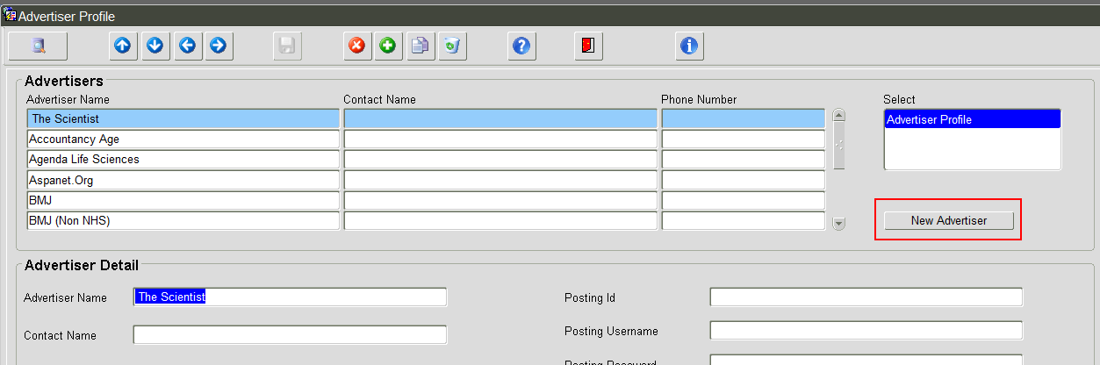

Advertising Codes - Portal

People Management>Data Centre>Reference Data>Advertising Codes

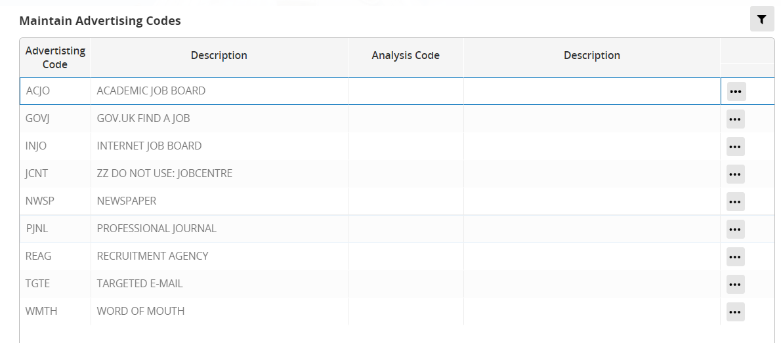

- Click on Add to insert a new row.

- Enter the Advertising Code and Description.

- Exit via the breadcrumb trail.
- Navigate to Core|Portal>Recruitment. Open a vacancy and click on ‘Costs and Advertising>Advertising’. Click on ADD ADVERT and check that the new code appears in the drop-down list.

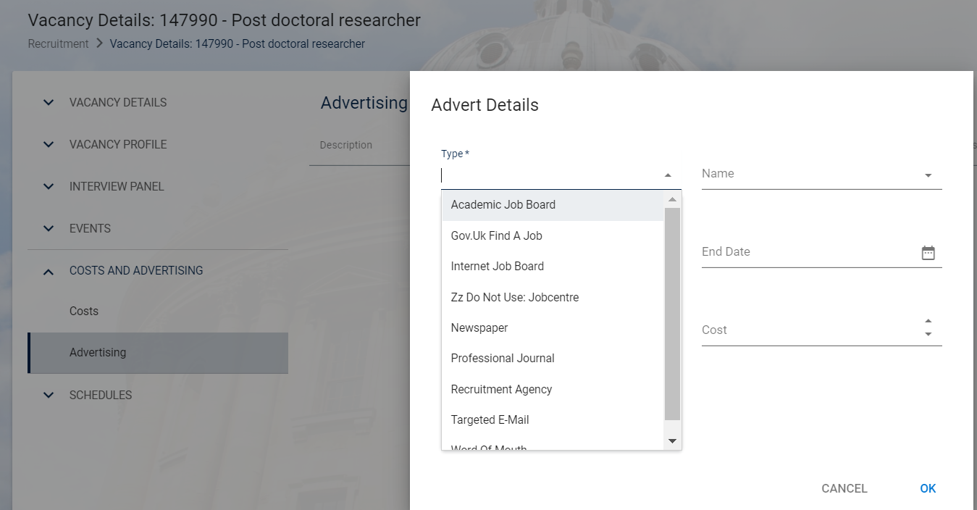

- Create a new staff request and check that the new Advertiser Details appear in the drop-down list.

Applicant Status – Portal

Core|Portal > Recruitment > Toolbox > Applicant Status

Applicant status controls some work flow in the system e.g. Applicant Status OFFP ‘Offer Made – Personnel’ triggers an additional step in Core, enabling the applicant to be appointed.

 | NB: Refer to the Core manual for more information before making any changes.

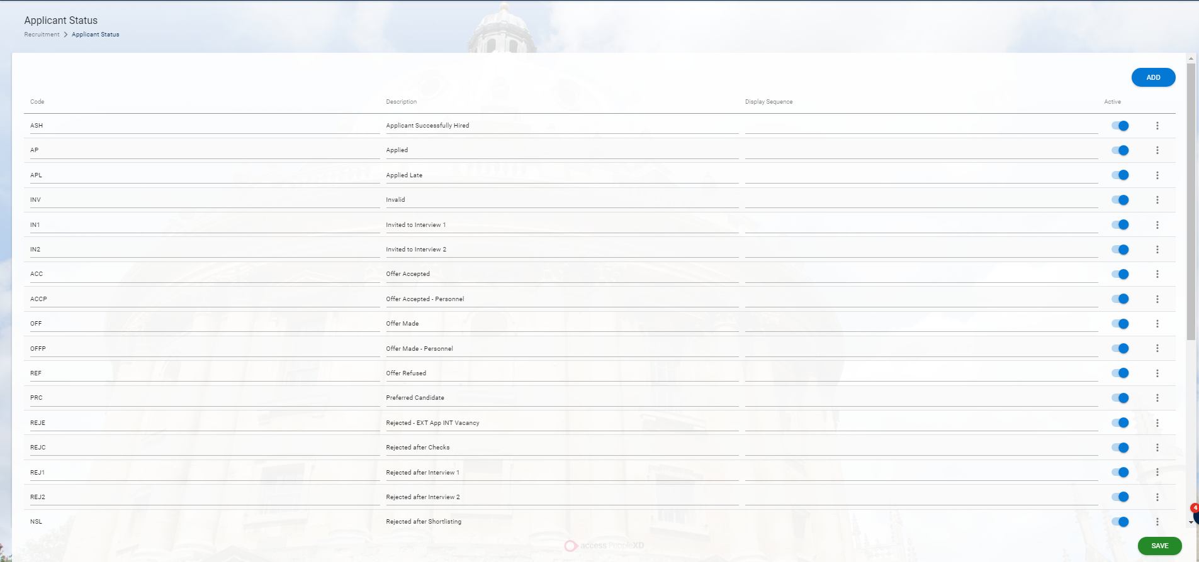

To edit the attributes for a status click on the ellipses (…) against the relevant status and choose ‘Status Details’.

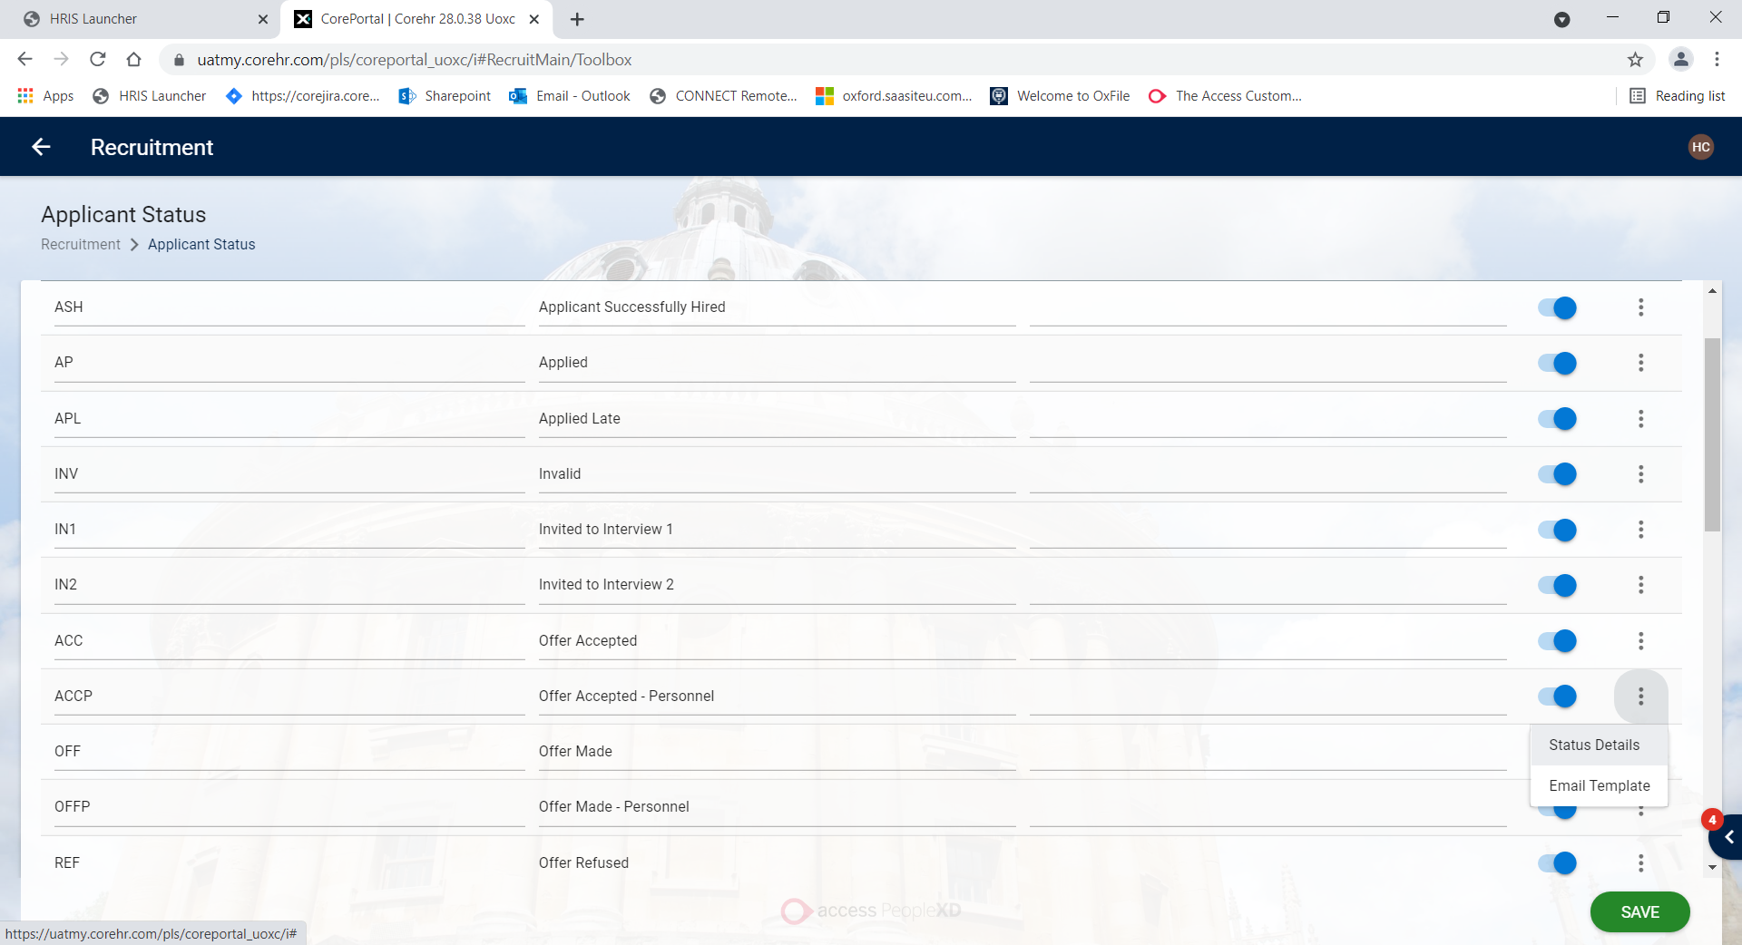

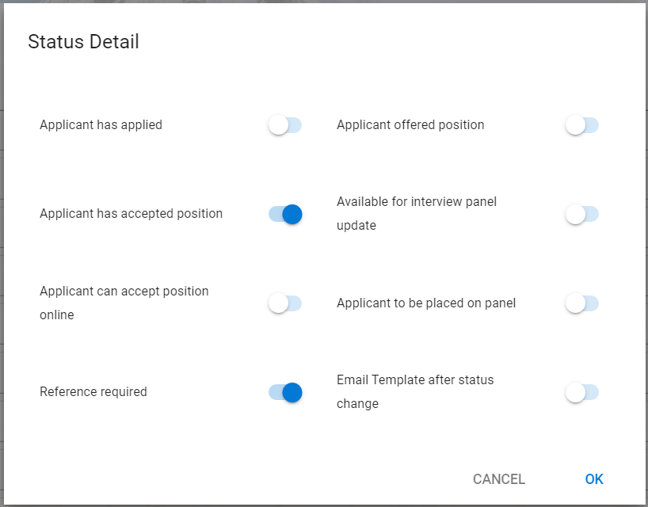

Applicant Status Sequence - Portal

Core|Portal > Recruitment > Toolbox > Applicant Status

Currently there are no sequences set against the applicant statuses. The back office screen is the same, so they have been removed at some point.



The default order is alphabetical by Description

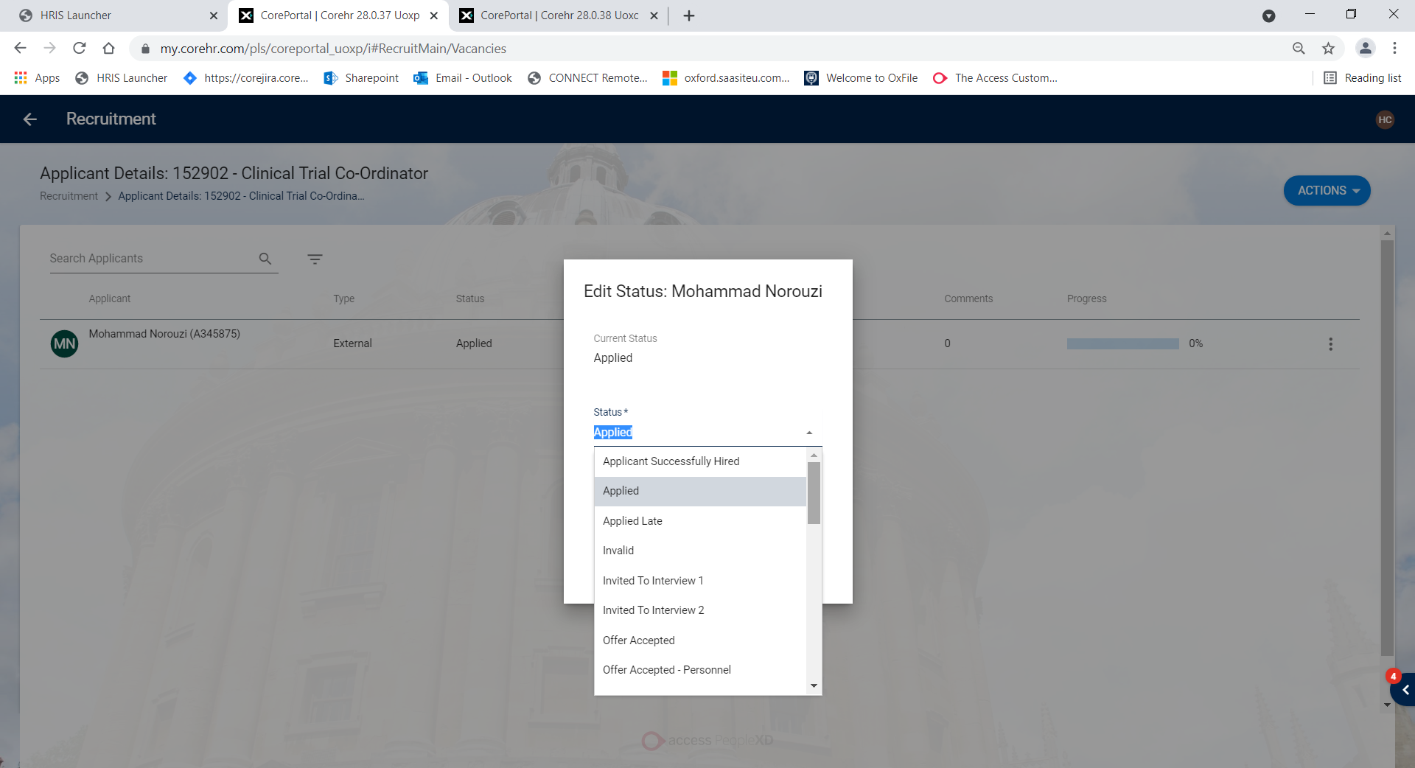

- To edit the sequence click into the Display Sequence box for the status you wish to edit. Up and down arrows will appear.

- Type in the sequence number or use the up/down arrows to set the sequence number for each status

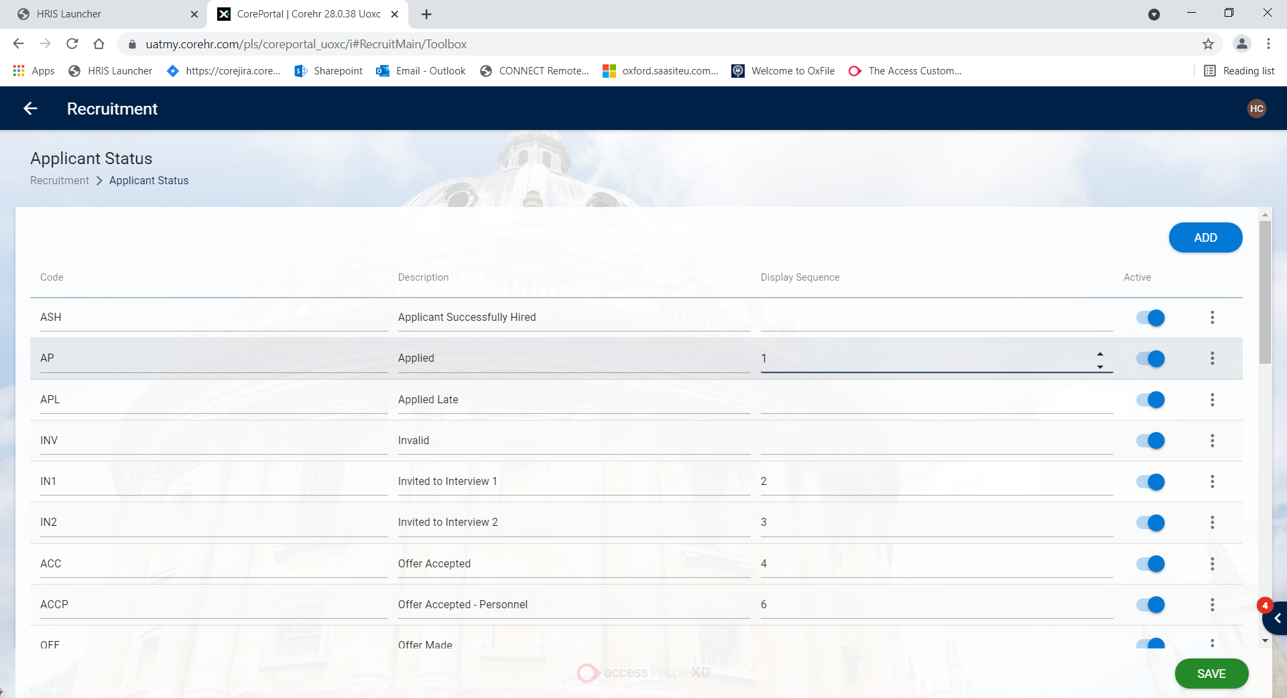

- Once you have added the required sequence numbers click SAVE.

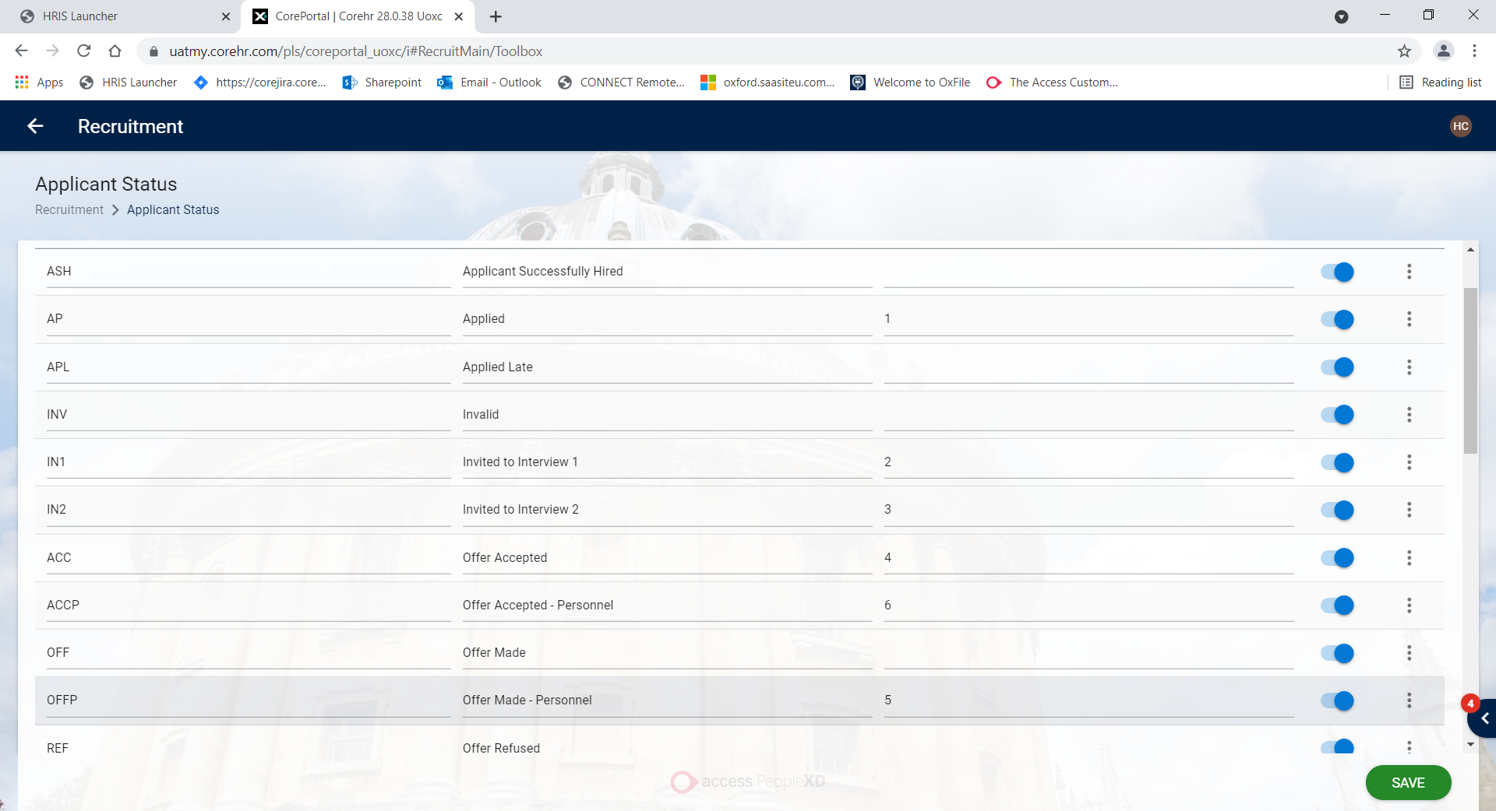

When editing an applicant status, the statuses allocated a sequence number will appear first in the specified order. Any statuses not allocated a sequence will display in alphabetical order below the sequential statuses.

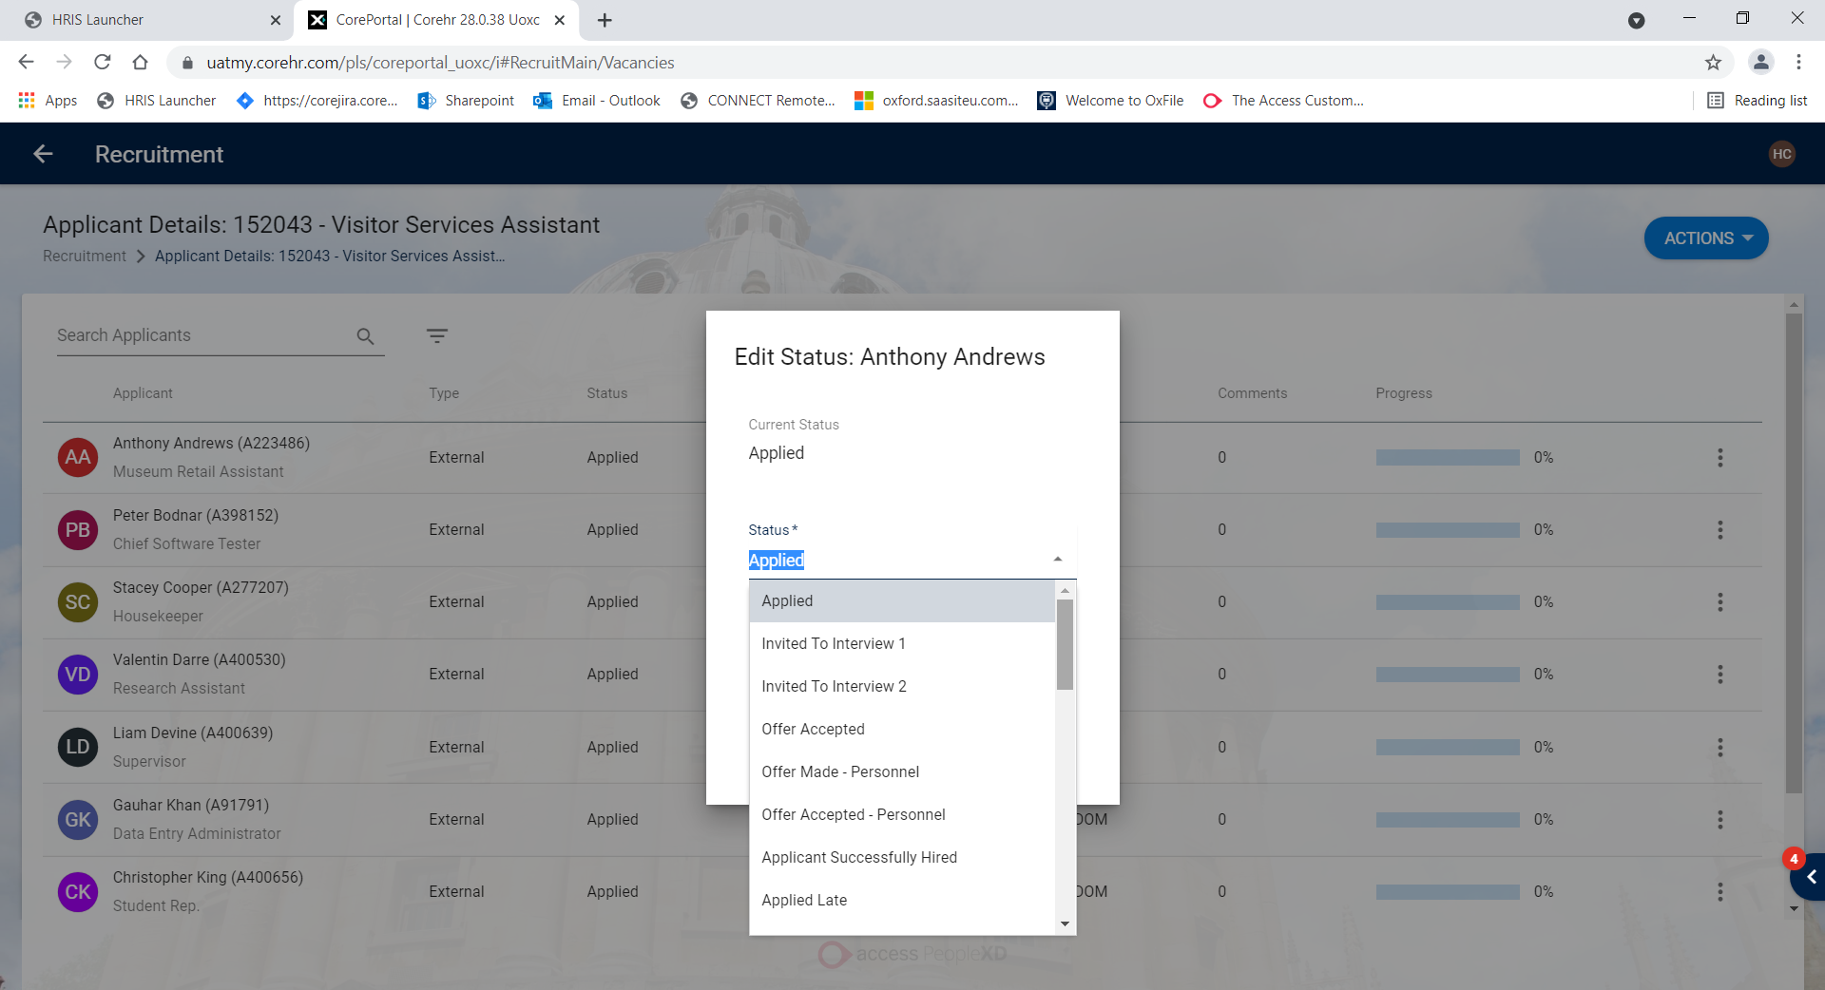

Bank Sort Code – Back Office

Bank Sort Codes are uploaded periodically using the bulk data migration tool. Further information can be found in the following knowledge article Upload Bank Sort Codes.

However, it is possible to make urgent amendments directly into the table, normally to add new entries.

Payroll Dashboard > Settings > Banking > Bank Details

Click ADD SORT CODE

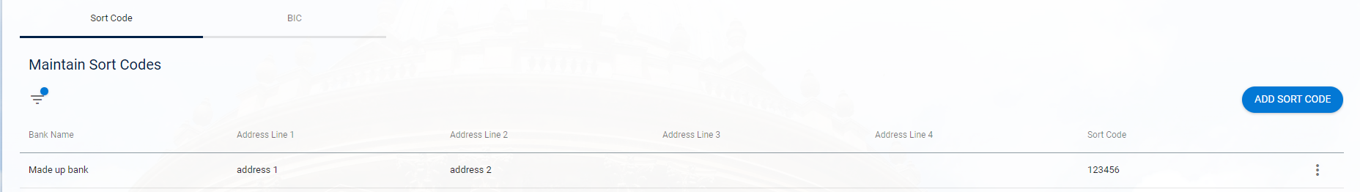

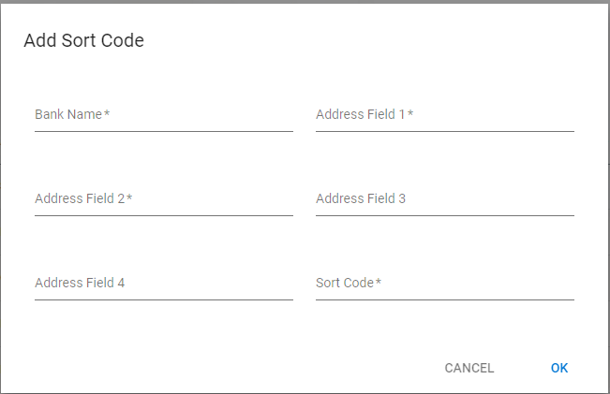

Company Settings

People Management>Data Centre>HR Admin Setup Settings>HR Configuration

Companies are not added very often but one thing to remember when adding a new company is to set the country field to UK. This controls the NI Number validation code used.

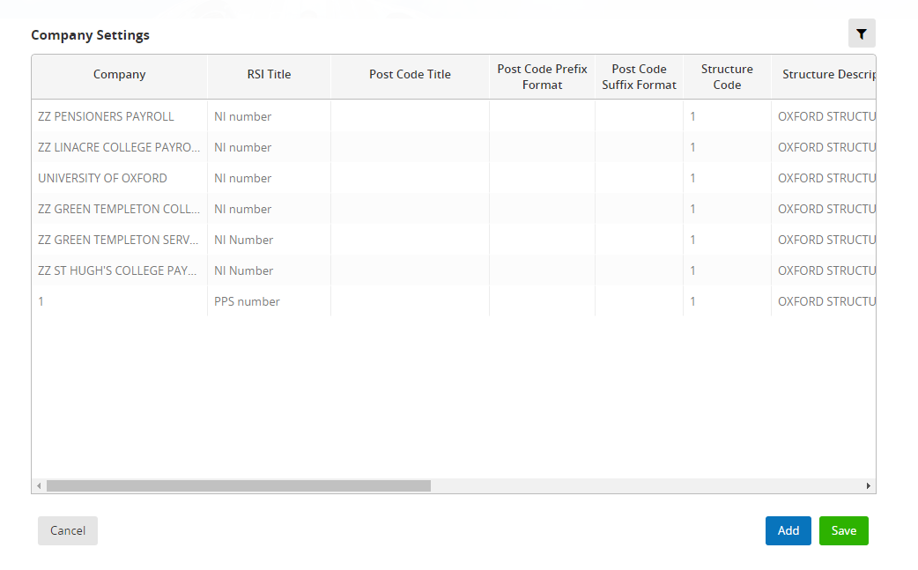

Click ADD to insert a new row

Contact Types - Portal

People Management>Data Centre>Reference Data>Contact Type

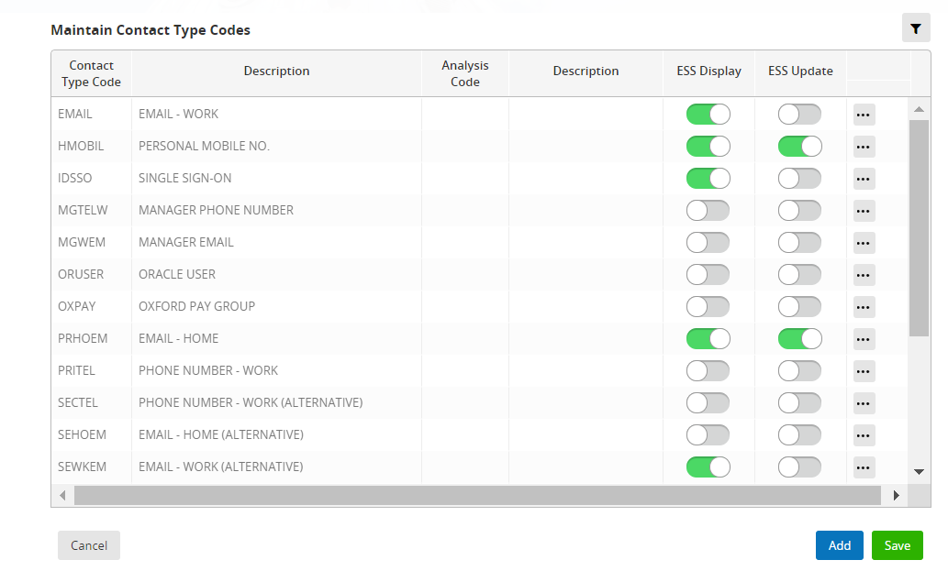

This control what employees can see and, if applicable, update in Employee Self Service, determined by the toggle buttons.

Education Codes (Qualifications) - Portal

People Management>Data Centre>Reference Data>Education Codes

Education/Skill codes are used in e-Recruitment, Personnel and HESA.

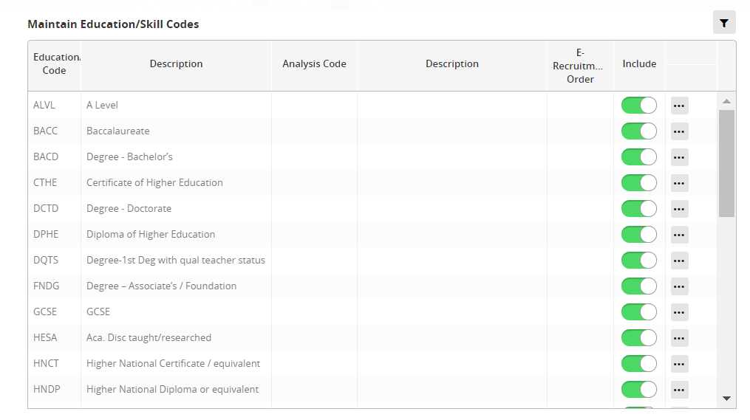

Employee Status - Portal

People Management>Data Centre>Reference Data>Employee Status

Not all Employee statuses should be made available to select on a Staff Request. Slide the Toggle button to include where applicable (this should be confirmed during the change management process).

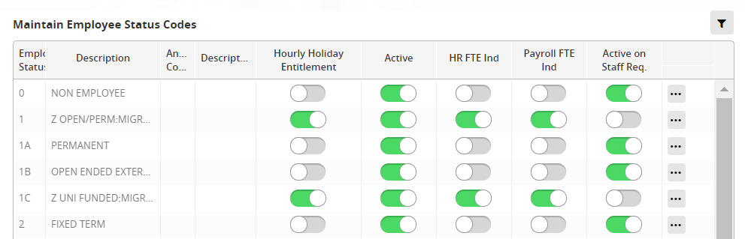

Ethnicity Codes (Ethnic Types) - Portal

People Management>Data Centre>Reference Data>Ethnic Types

The description is prefixed with the code so that the list is ordered in the correct sequence on the applicants pages of e-Recruitment.

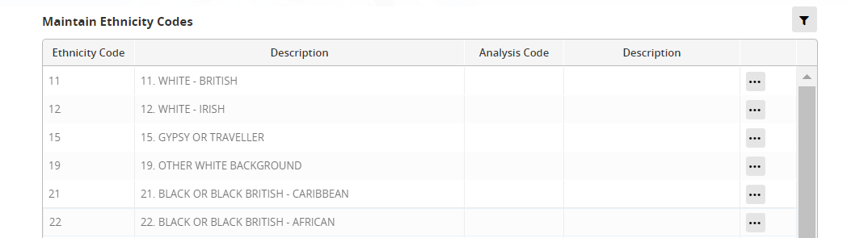

FTE Hours - Portal

People Management>Data Centre>Reference Data>FTE Hours

The standard FTE hours are 0.00 for Casuals and Non-employees, 36.5 for grades 1-5 and 37.5 for grades 6 and above. However, there are other FTE hour values in use for certain roles.

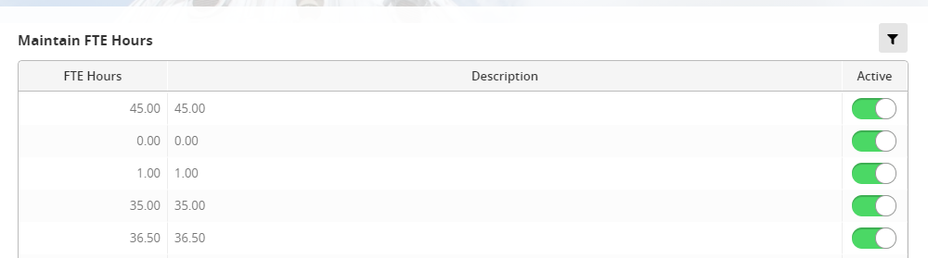

NB: When adding any new values ensure that the Active toggle is selected.

Job Title Codes - Portal

People Management>Data Centre>Reference Data>Job Title Codes

This reference data is also known as Post Title and contains a list of generic job titles. A generic job title is not supposed to reflect seniority or other distinctions that can be differentiated by grade.

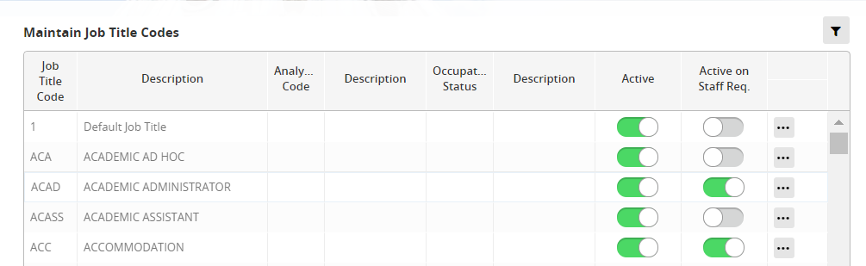

Not all Post titles are active on Staff requests. These are usually titles that have been used in the past (and may still be present on active appointments) but are no longer to be used.

Marital Status

Marital status is not recorded in Core but the system will set a default on all applicants and employees as the record is created. Therefore the 2 values used (S and O) must remain in the reference data table

Payment Methods – Portal

Payroll Dashboard > Settings > Banking > Payment Methods

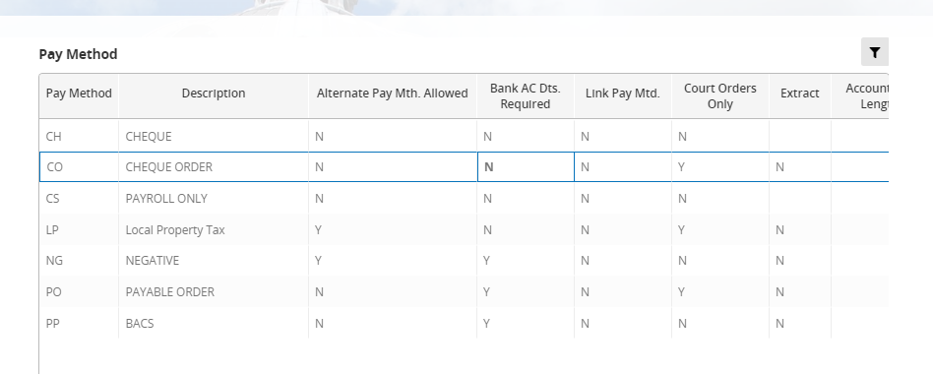

Pay Method reflects how an employee’s salary and allowances are to be paid to them. The configuration here will interact with Corepay and therefore any changes/additions must be discussed and agreed with payroll and the Corepay system owner before proceeding.

Pay Scale, Point and Rates

These items and how to administer pay uplifts are all covered by separate guides. HOW TO - Manage Grades and Rates and Pay Uplift Procedures

Personnel Numbering – back office

People Management>Data Centre>HR Admin Setup Settings>HR Settings

Employee numbers are controlled by personnel numbering. Current configuration is for them to be generated automatically and be 7 digits long without any prefixes or suffixes.

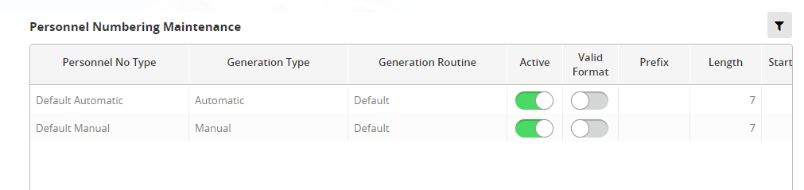

There is also an option to manually enter an employee number during the appointment process. This has occasionally been used in special circumstances e.g. for REF reporting.

Profile Analysis Codes

Personnel > Reference > Reference K-P > Profile Analysis Codes

Otherwise known as Post Analysis codes. These are used by the Reward team to record activity when creating posts. They have no other use or effect so can be added to at the request of the Reward team.

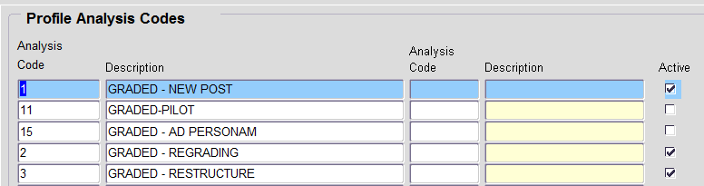

The codes can be viewed, created and edited in the Portal via People Management > Reference Data > Profile Analysis Code but there is no active/inactive indicator.
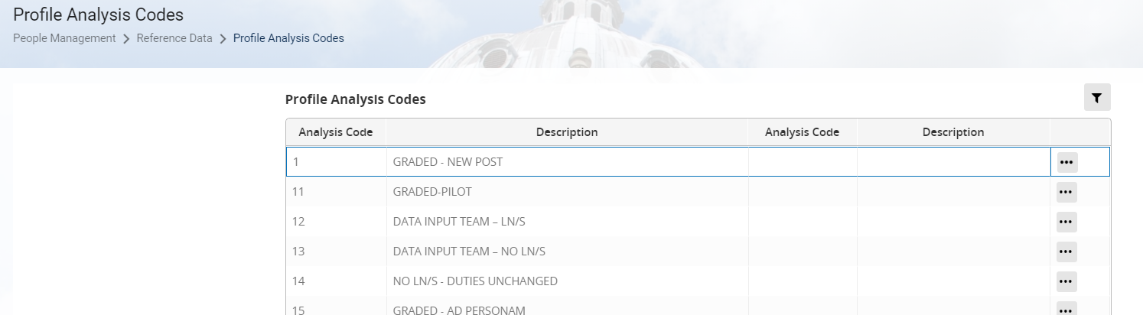

Reason Codes - Portal

People Management > Reference Data > Reason Codes

This reference data set is also known as “Change Reasons” and “Appointment Reason Codes”. It contains a list of codes which describe changes to appointments, generally those which will require a new post-sequence to be created.

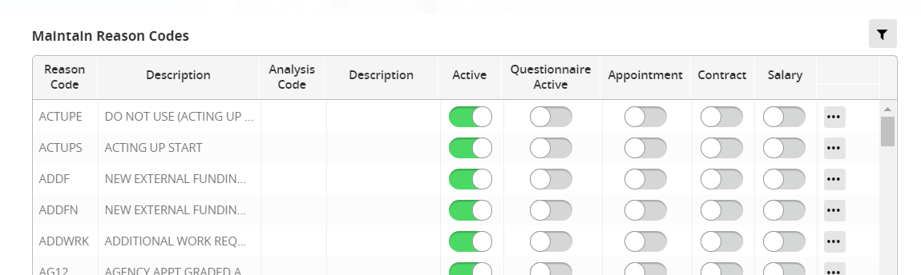

Personal Title – Portal

People Management > Reference Data > Title Setup

Titles marked active are available to use in People Management and e-recruitment. See the list of current active titles.

 | NB: The screen takes several minutes to load and as a result the active titles are not displayed immediately.

- To add a new Title, click on ADD to insert a new row.

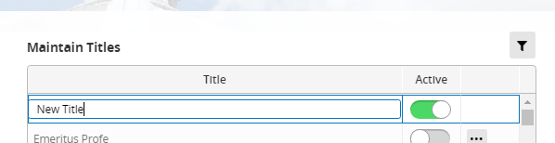

- Enter the new title. (The Active button is ON automatically)

- SAVE and OK the confirmation message

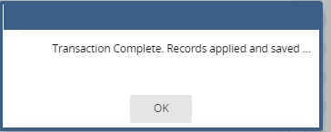

- To remove a title from use, locate it in the list toggle the Active button to OFF

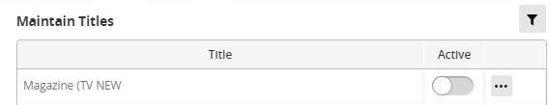

Leaving Reason – Portal

People Management>Data Centre>Reference Data>Leaving Reason Codes

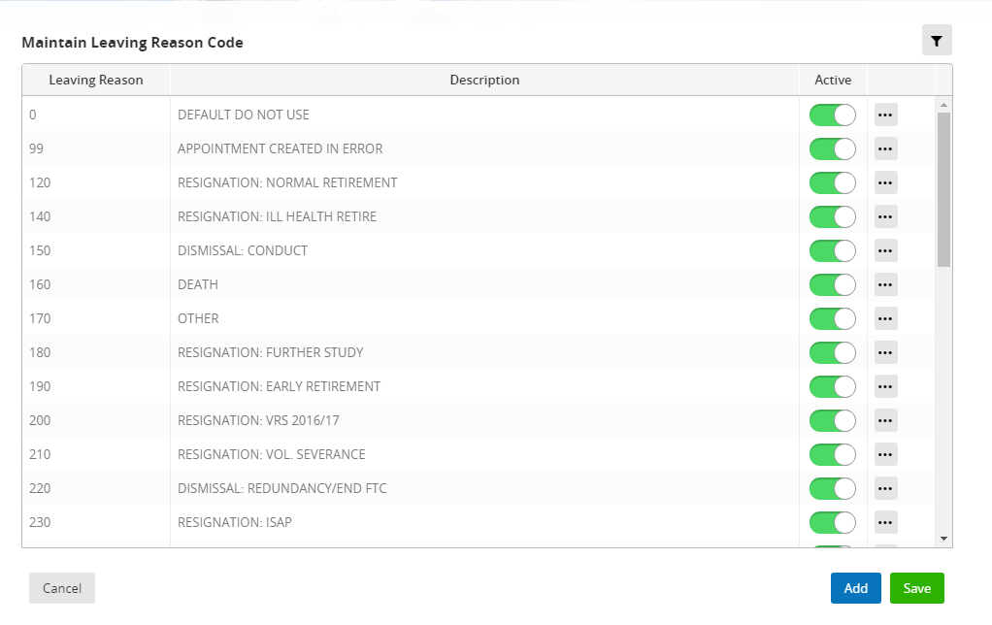

- Follow the steps in Section 4

Leaving Destination - Portal

People Management>Data Centre>Reference Data>Other References

- Enter or search for Reference Type LVDEST

- Follow the steps in Section 4

Location after Leaving - Portal

- Enter or search for Reference Type LOCLEA

- Follow the steps in Section 4

Recruitment Status Codes

People Management>Data Centre>Reference Data>Other References

- Enter or search for Reference Type RECSTS

- Follow the steps in Section 4

